### ***EventNow***

### 

### 

**By: DAAACMSS**

### **Kasse Al-Bezargan, Alejandro Angeles, Daniel Chavez, Deman Das, Eric Maso, Sean Peart, Christopher Serrano, Andrew Sigalas**

### 

### **Professor Douglas Zytko**

**CSIT-335: Intro to Human Computer Interaction**

**Course Section 01**

**Montclair State University - Fall 2017**

### **20 December 2017**

### **Table of Contents**

**Table of Contents** **1**

**Project Summary** **2**

**Understanding the Problem Space: Semi-structured Interviews** **3**

**Identifying Target Demographic And Problem Statement** **4**

**Personas** **5**

**Problem Scenarios** **10**

**Lightning Demos** **17**

**Card Sorting and Vision Statement** **24**

**Context Scenarios** **27**

**Key Path Scenario** **35**

**Usability Test** **39**

### Project Summary

We've started by identifying a phenomenon that technology could intervene in: students generally have no school-based social network when they start college. We want to make the process of forming a social network in college...easier. We want to understand how students go about forming a social network when they enter college and we want to be able to identify struggles that they encounter when doing this. This understanding will inform hypotheses about specific problems that we can design and evaluate solutions for.

Problem Statement: First year students at MSU can’t always attend the events they want to.

Explanation: Many of the students who are unfamiliar with MSU tend not to know about events or have schedules that don’t allow them to attend certain events. As such, we look to help them get an equally worthwhile experience.

Vision Statement: First year students at MSU can get an experience similar to attending an event without needing to physically be there.

Explanation: We believe that there is opportunity for first year students to attend events without the need to set time aside to be there is person. They can get an equally impactful take away from an event by interacting with the people who are in attendance as well as watching the event live as it happens.

### Understanding the Problem Space: Semi-structured Interviews

We started off needing to know who our possible audiences might be. We selected a new student to Montclair State University (MSU) to interview as well as 2 members of our team. While we understand that interviewing members of your own team is not a good sample, we did so in the interest of time, as we had trouble finding students to interview before our deadline. We organized a couple questions that we each wanted to ask before sitting down with each of our 3 interviewees.

We discovered some themes such as minimal drive in making new friends on campus or attending any events, that the people we interviewed were content with their current friend group, and that being living on campus had no innate effect on increasing their drive to get new friends. As a class, we pooled together all of our results and instead found a few even larger themes amongst interviewees. We found that many people feel they don’t have the time in their days to make friends, some were too shy to approach new people or attend new events, and others who felt they didn’t need to make new friends. For our purposes we decided to focus mostly on those people who felt they didn’t have the time in their schedules to create new friendships.

### Identifying Target Demographic And Problem Statement

After deciding on a general topic, we began to focus on narrowing down the main theme we had in mind into a problem statement. The problem statement will focus on what problems our personas had in common and what sort of background they share. We began with that theme of time management and decided on first year students because they would be the most in need of forming relationships, being that they are new to MSU.

Now that we had a problem statement to begin with we started to personas (see next section). In the process of forming each persona we simplified their big issues down further and further until eventually finalizing our focus. Settling on events as a primary goal, we arrived at our problem statement: First year students at MSU can’t always attend the events they want to.

### Personas

Given the broad nature of the problems we have identified, we grew familiar with the benefits of deploying the use of personas, which are imaginary but much very brought-to-life individuals that are encapsulated by personalities, goals and frustrations. As Shlomo Goltz of Smashing Magazine puts it, each persona represents a significantly large group of people in one condense character, which allows the designer(s) to focus on more manageable tasks, instead of focusing on thousands of individual needs and desires.

We carefully pieced together our personas so that they cover a diverse range of goals and backgrounds. For example, we gave birth to an eccentric soul named Sinbad, who was seen in whatever sparse free time on campus with his group of friends but is piled up by poor time management. When we presented Sinbad, we realized we had not portrayed our problem properly, and moved him to the sidelines until we could better portray him.

|  |  |  |
| --- | --- | --- |
| Sinbad Ali *“I aim to please”* | | |
| https://farm3.static.flickr.com/2417/2157831185_341b962bde.jpg | **Background**   * Age: 20 * Role: The funny guy * Major: Sophomore in Computer Science * Computer Experience: Above average | **Main Points**   * Interested in computer security involving hacking * Has small group of friends with intentions of networking out towards others * Tries to stay physically fit through hiking and eating healthy * Struggles in maintaining both academic and social life |
| **Goals**   * To better manage school work and personal life * Network for future career opportunities * Keep a close group of friends on campus * Get a job as a white hat hacker | **Narrative**  Sinbad is a Sophomore transfer student at Montclair State University (MSU) majoring in Computer Science (CS). He enjoys majoring in CS because he wants to become a white hat hacker. Sinbad began to work in hacking playing RuneScape, where his account was hacked and he worked to get it back. Ever since then, he started learning about computer security and found joy navigating through and around security systems. He experiments with tools such as Nmap, Kali Linux, THC Hydra, and Wireshark.  As a commuter, Sinbad relates with the struggle of parking at Car Park Diem. He was part of the CS club in his first semester, but had to drop it due to time constraints. Sinbad thinks the food at MSU could be healthier, so he always goes off campus to buy food from other places or even brings food from home if he has the time to prepare it. Sometimes, these food runs make him a few minutes late for class. He wants to graduate by the end of 2018 so he can go backpacking through Europe with his friends to wind down after college.  Sinbad has a small group of 5 friends on campus that he met mostly in class and one friend he met from the CS club his first semester. He can occasionally be seen eating with them with during his breaks. He loves to laugh and make his friends laugh through hissarcastic comments and his terrible jokes. Heis satisfied with his close-knit group,but finds it hard to meet up with them outside of going on food runs together. He would much prefer being able to spend time with them at campus events during these breaks, but he also feels food is a much bigger priority.  Sinbad would like to build a social network to help him seek out career opportunities after he returns from his trip to Europe. Sinbad finds classes overwhelming because his professors assign homework for several classes on the same day and often Sinbad has to prioritize which work he wants to hand in. Lately, he has had several group projects assigned to him. He feels the need to prioritize helping his group mates with these projects over doing his other assignments or even having fun with friends. He hopes that if he proves himself to be a hard worker they will think of him that way when it comes time to look for a job. | |
| **Frustrations and Pain Points**   * Finding time to spend with friends * Missing campus events and extracurricular studies * Finding parking on Campus * Managing class workloads |
|  |

In the meantime, we shifted our focus to Bob, who was more believable with his goal to kickstart his drive in meeting people and demands in expanding his social network . He wasn’t without flaws though, as he too was misrepresented, albeit to a lesser degree than Sinbad. Because of this, and deadlines approaching quickly, we decided to focus solely on Bob for now, while still changing Sinbad and our final persona Tom in ways that wouldn’t change who they were but the problem they had.

|  |  |  |
| --- | --- | --- |
| Bob Kooper *“Nothing comes easy.”* | | |
|  | **Background**   * Age: 18 * Role: The hardworking student * Major: Freshmen in Computer Science * Computer Experience: Intermediate Level | **Main Points**   * Interested in app development * Has a small group of friends * Makes efforts to network when able to * Attempts to balance friends, school and his full time job |
| **Goals**   * To become an app developer * Network to land a job in the future * Expand his group of friends * Make one of the greatest apps of all time | **Narrative**  Bob is currently a freshman at Montclair State University, majoring in Computer Science. He has always been interested in programming even in his earlier years. He tried his best to self teach himself what he could before coming to college and got a good handle on some java. He has attempted to make basic websites with plain text and images and got excited when he made his hello world program with java. He eventually decided that he would want to become an app developer after graduation when he saw that people were developing apps for android with java and android studio. He hopes to one day develop an app as big as Flappy Bird and have everyone using it.  Bob throughout the first half of his semester struggled to make friends. For the most part he would just sit down somewhere on campus in his short 30 to 45 minutes gaps and relax because he doesn’t believe that is enough time to settle down and really get into doing homework. He has to wait until he gets home to do homework so he can focus. One day in class he was able to make one good friend through a group assignment in one of his gen-ed classes. She was kind enough to introduce him to her group of friends. Now Bob has a small group of 4 friends who he meets with during his gaps. Previous to this it was difficult to meet anyone because he was always so busy juggling a full time job to pay for school, doing school work, and making the commute from school to work and home. With so much in his hands the last thing Bob is thinking about is attending campus events or joining clubs. In his classes he would tend to keep to himself because socializing was never his strong suit. Bob would only talk to others if someone talked to him or if he was put into a group. Although he has a small group he also want to try to make new friends, but knows work, class work, and commuting gets in the way.  On rare occasions classes are sometimes cancelled for him or he has a day off from work. On these days he attends career fairs on campus, workshops,events where speakers come on campus, or other conferences within the area that day. If not that Bob would be seen hanging out with his friends on campus all day when he has the chance. He and his friends would all be gathered together at the student center and be the most loud and obnoxious group of people. They would all crack jokes, talk about the most ridiculous of things, and would be seen running around the student center.  As a freshman in college, he is focusing on school as much as he can, especially in the few computer science classes he is taking. He does his best taking notes, asking questions, keeping up with attendance, etc. He feels those are going to be the classes that will help him become a better programmer. At times he gets overwhelmed from the workload, but tries to remind himself of the end goal which is graduation and holding onto the idea of being an app developer. | |
| **Frustrations and Pain Points**   * Time management * Having a hard time making friends * Being a commuter * Being overwhelmed by schoolwork |
|  |

Our final persona we worked on was Tom. Tom was a chemistry major who had dreams of becoming the head of his favorite club. However, this just wasn’t possible under his current schedule. Tom had to work part-time to pay for school and so he couldn’t attend any of the meetings. We believe Tom was the weakest of the three personas, and that he needed more work to be fully realized, and so he too was put to the sidelines as we focused on Bob.

|  |  |  |
| --- | --- | --- |
| Tom Veerman *“I love discovering new things!”* | | |
|  | **Background**   * Age: 19 * Role: Enthusiastic * Major: Freshman in Chemistry * Computer Experience: Just below average | **Main Points**   * Spends most of his time working, whether it’s class or his job. * Stresses over not having enough time to network. * Dives into extracurricular activities to expand and maintain his passions. |
| **Goals**   * Graduate early as a chemistry major and get into research. * Keep a close group of friends on and off campus * Wants to lead a club | **Narrative**  Tom is a first year commuter student majoring in Chemistry. He spends most of his time working and studying in his field of study. At a young age, Tom always found chemistry to be a fascinating subject. The idea of certain molecules interacting between one another to result in either a positive, smooth outcome or a devastating destructive explosion interested him. To discover all types of possibilities. This is what drives Tom.  Within the two introductory chemistry classes he’s taking this semester, Tom has grown friendships with a few of his classmates, with commonalities such as *Breaking Bad*, sports and the need for study groups to support each other academically and mentally as their coursework grows exponentially more demanding. Most of them are commuters and are also enrolled in gen-ed requirements different from each other, providing obstacles in catching up outside of class. One of them, however, dorms and is more available to partake in the social life on campus, so Tom wishes to arrange activities such as playing video games and pickup basketball at the Rec. Even though Tom has some time with his classmates, he doesn't have the time to connect with other people outside of his field aside from the clubs he attends.  On Tuesdays and Fridays, he takes the train back home and goes to his part-time job as a sales associate at Foot Locker. Of course Tom doesn’t really like his job and it has nothing to do with his studies, but Tom needs the money to make up the commute he takes to school and his books. Tom hope’s by Junior year of college, he will land a paid internship job in his studies near campus and drop his Foot Locker job. This would allow him to connect more with people in his studies as well.  Tom wants to take 15-18 credits every semester so he can graduate a semester early and begin his career in lab research. He has joined clubs such as the Video Production Club and the Chemistry Club, in which he tries to convince his chemistry classmates to attend the latter as they would provide productive experiences enhancing their studies. He aspires to attain a leadership role with the Chemistry Club one day, yet he cannot make it to all of the meetings and events due to his schedule. He values the personalities and interactions with the students and professors he has been introduced to and seeks building upon these relationships much more closely within the fast-paced curriculum he intends on setting. | |
| **Frustrations and Pain Points**   * Not enough time to network * Missing interesting events while on campus. * Only has time to make friends on campus in between classes. * Commute schedule leaves narrow window in campus presence. |
|  |

### Problem Scenarios

Now that we have our personas built up as believable as possible, we want to focus on what their daily life is like before the introduction of our app. Clearly our app isn’t sent from the heavens to save the lives of miserable college students who don’t have our app, but our app has a clear niche that it can help. We focused on making the lives of our personas decent, but with a desire to do more with the time they have.

Bob wants to attend the career fair after his class are finished. He attends the career fair and is there for a little over an hour. Then Bob proceeds to go work and arrives 20 minutes late. While at work, Bob’s friend calls him and ask if he is going to attend the mobile development conference. Bob had no idea that an event was at Montclair that day. Bob wishes he could have attended the mobile development conference, but he couldn’t since he had to leave early to go to work.

**Bob Kooper’s Problem Scenario and Storyboard**

It is Wednesday and Bob wakes up at 7:00 am and goes to the bathroom to wash up. He finishes at 7:30 am and goes to the kitchen to make breakfast. He finishes breakfast by 8:00 am and then gets into his car and drives to MSU. Bob arrives at MSU at 8:30 am and has trouble finding parking in the lots. It took him about 10 minutes to find a parking space and goes to the Student Center to see his friends. He hangs out there to talk, relax for a bit, and then goes to class. Bob has two classes today, which are Fundamentals of Programming I at 9:00 am and Computational Concepts at 10:30 am. Since he has a 15 minute break in between classes and has his next class in the same room, he decides to stay and wait in the room with everyone else who has the same class as him next. While waiting for the break to end, Bob begins to think about the career fair he is going to attend at 12:00 pm. He begins to stress out because he only just found out about it yesterday, and so only had one night to prepare for it. He feels that his resume looks like a barren wasteland that has no experience related to the CS field. He wonders who would even hire an intern with no experience. As his class ends at 11:45 am, he rushes to the Student Center and meets up with his friend who agreed to attend the career fair with him. He is in a rush because he has to be at work by 2:00 pm and it takes Bob 45 minutes to get there from MSU, so time is not on his side.

Bob and his friend go to University Hall and take the elevator to the floor where the career fair is at. They enter the room and see many panels. There are so many that Bob questions whether or not he will be able to go to all the panels and speak to the recruiters. Before he came to the career fair he made a specific list of which companies he primarily wants to go see. Those companies were Amazon, UPS, ADP, and Colgate Palmolive. Although those companies were his primary focus there was 50 companies attending the fair and he wanted to hand out all of his 35 resumes if possible. The first panel they want to see is UPS, which is Bob’s first priority on his list, so they get in line to talk to the recruiter. Unfortunately, Bob spent a long time in line, so by the time he got to talk to the recruiter 20 minutes had passed by. He thinks to himself “No wonder the career fair is from 12 to 4.” The school made the event so long so students can go up to all the panels they want to.. Out of all 50 panels he was only able to go up to 10 panels which seemed like nothing. Bob is infuriated because he is missing out on an amazing opportunity to network with people just to go to work. What made matters worse was that Bob didn’t realize how much time has passed because he was so focused on talking to the recruiters. It turns out he ended up being there for more than an hour and a half. Bob realized the time and began to panic and rushes to work before he’s too late.

He then proceeds to rush to his car, infuriated that instead of wasting precious time at work he could be staying at the career fair to continue networking with others and possibly land an internship that pays more than his current job. Times like these he wishes he would have known about the career fair sooner. Bob arrived at the parking lot and sped to work, but unfortunately he got there about 20 minutes late and was reprimanded. While at work his friend called him to ask if he was going to the mobile development conference and workshop that starts at 3:00 pm. Bob had to tell his friend that he couldn’t attend it because he never knew it was even happening, but he really wishes he could have gone. Bob’s friend told him that they got an email about it last week, but that it was buried underneath all of the other events for that week. Bob realized he was spending too much time on the phone and hung up, but his mind was still stuck on the idea that he just never knew such an important event to him was happening. He wants to just leave work and go back to attend but it’s already too late. Now he won’t have the chance to talk to other people interested and working in app development. When he got home that night he looked at the email he had gotten at the beginning of the week and wrote down all the interesting events to him, checked his own schedule, and planned out whether he thought they were worth going to or not. One in particular stood out to him. It was a team-based 3 hour event to create a simple app for the school. This could be his second chance at making connections with other students with a common interest in app development. After several weeks, Bob realized that he wasn't going to get any call backs from the jobs he looked into from the career fair.

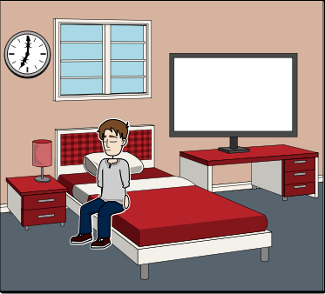 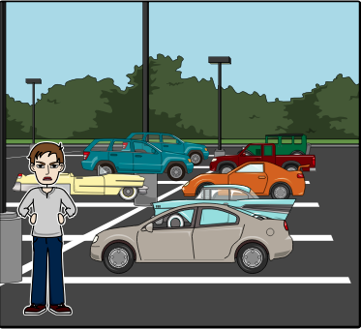

 

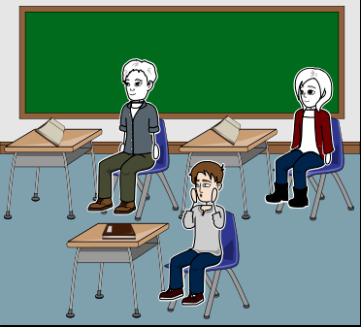 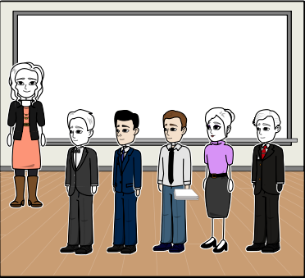

 

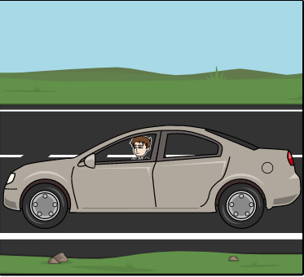 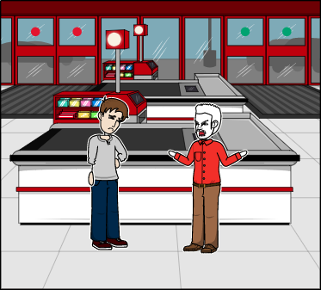

 

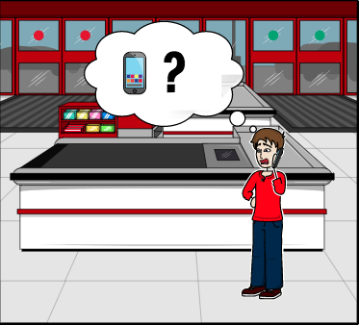 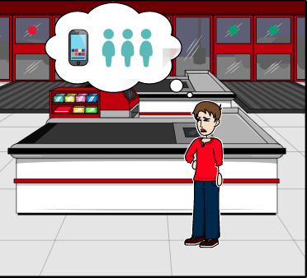

 

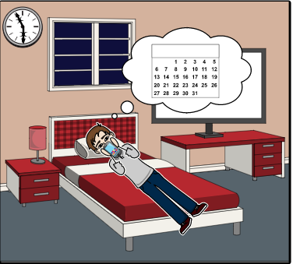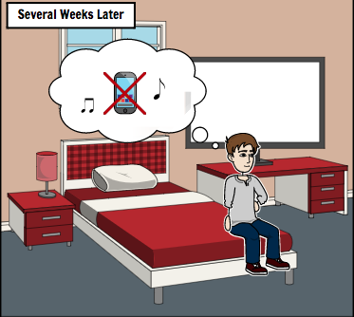



Tom frequently goes to the Chemistry Club on Wednesdays and discusses interesting chemistry topics with other club members. One Tuesday, his classmates from General Chemistry I class asked Tom to come visit the club that afternoon. Tom had work to go to that day sadly, but he was a bit eager to see what they were going to discuss about and wanted to meet the different people that were there. He decided to go even with the short amount of time he would be challenged with. When he went, he had less than 30 minutes and didn't really connect with anyone because of the short time. To make matters worse, he missed the opportunity to meet a nice lady friend that he could connect with. He gets to work, finishes up and goes home.

**Tom Veerman’s Problem Scenario**

It’s Tuesday and Tom wakes up at 7:00am. He washes up, gets dressed, and heads straight to the train station to catch the 8:00am train to MSU. Tom never feels hungry enough in the morning to eat breakfast, so he just waits until lunch. When Tom arrives at MSU, he gets to his General Chemistry I class at 9:30am. He talks to his friends about the Chemistry Club and what they are going to discuss at 5:30pm tonight. Tom can’t make it to this event because he has work later at 6:00pm, but his classmates insist that he at least swing by and hear the discussion that they would have. Tom considers it. When class is over at 10:45am, Tom goes to his next class, Calculus I from 11:00am to 12:15pm. Once that class is done he goes to his next class, University Physics I at 1:00pm. During this class, Tom decides that maybe he should take a look at the Chemistry Club and what they were going to discuss. Tom could only make the Wednesday meetings, not the Tuesday ones, but he does think it would be interesting to see what they talk about today.

Once Tom was done with University Physics I class at 2:15, he goes to the Student Rec Center to eat his lunch. Tom takes the extra time he has to study his notes. If Tom was going to go to the Chemistry Club at 5:30pm, he would have to hurry to the train station before 5:45pm, because that’s when the train leaves to go to his job at Foot Locker. 5:15pm rolls by and Tom starts heading to the Chemistry Club. He gets there on time and hears the discussion they have. There are a lot of interesting people there that he hasn't met before. Time moves quickly and it’s 5:35pm. Tom needs to hurry and leaves the Club’s room. Just before he turns around the corner of the hallway, he notices a gorgeous girl walk past him and enters the Club room. Tom has never seen her before. She must only come to the Club on Tuesdays. Tom can’t stop to talk to this girl, he has got to go. He quickly gets to the train station and makes it by the skin of his teeth.

Tom makes it to work in one piece. During his shift, he thinks about the discussion at the Club and that girl he passed. He wished he could have more time to pursue these things, to better craft his current knowledge of Chemistry and a chance to discover a partner that he could have ‘chemistry’ with. After his day at work, Tom heads home around 10:00pm. Before Tom goes to sleep, he asked his classmates in a DM if they knew the girl that came in after he left. Tom felt a little creepy asking his classmates who she was. They say that they knew her and that she’s a Computer Science Major who had a interest in chemistry on the side. And on that note, Tom falls asleep at 11:00pm. More things await for Tom tomorrow…

Sinbad is a rather busy man. His first semester went pretty smooth, and he got to do a lot of what he set out to accomplish. This semester is a bit different for him though, as he now has a couple of projects that he is trying to focus on getting done. Because of this, he no longer has the time to attend the Computer Science Club anymore. He still makes the effort to spend what little time he has to visit the club from time to time.

**Sinbad Ali’s Problem Scenario**

Sinbad has only been at MSU for a little over one semester, but he feels as though he has yet to make any progress on building a large enough network to fall back on for work after his trip to Europe. In his first semester, Sinbad managed to build the friend group that he is happy with. Outside of that, he felt he really needed to step up his efforts in acquiring acquaintances. To do this, he focused on attending any club he found some interest in, and went to any event on campus that he had the time for. While he did meet one of his closest friends at CS club, he never had the chance to build a strong connection with anyone else.

This semester has been much harder on Sinbad’s schedule. He attends classes from Tuesday to Friday starting at 1pm.. He starts his day waking up at 10am and getting ready for his class at 1pm. After his 1 o’clock class he goes to grab a bite with his friends and comes back to campus for his class at 2:30pm. After his 2:30pm class on Tuesdays and Thursdays he attends group meetings for his project in Computer Security. Usually these meetings only take a little under 2 hours to finish discussing what everyone needs to do, as well as a bit of off-topic discussion about classes they have or had in common. Last Tuesday was different for Sinbad and his group, as one particular issue gave them a great deal of trouble. That night he didn’t leave campus until 7:20pm. When he got home at 8pm he ate dinner and tried to work on his assignment due tomorrow, but was too tired to finish it before he went to sleep. His Wednesday schedule is a bit different. First, he has no group meeting after his second class ends at 3:45. Instead he has another class at 4pm. He spends this 15 minute gap to pop in on the CS club for 10 before it ends before heading to class. At the CS club he only gets to talk to the few people who stuck around until the end, one of which is the friend he met last semester. He then stays in class until 6:30 and heads straight home to do homework. Friday he returns to his 1pm to 3:45pm schedule, with a group meeting for Software Engineering after classes are finished. His group for Software Engineering is a bit more down to business than his Computer Security group. He gets the feeling that they just want to get the work done and get out of there, so he does the same. He then heads home to get started on homework after spending an hour with his groupmates.

Sinbad’s weekends and Mondays are mostly dedicated to catching up on work for the rest of the week. He spent all of last Saturday doing the future work outside of group projects for the week so that he can spend as much of the his free time focusing on his group projects. While rare, sometimes Sinbad has no group work due for the week because his groups are ahead of schedule. So far, there has only been one week when both groups had no upcoming work, and 2 weeks when he only had work to do for one of his projects. When this happened, he had no real plans on what to do so he tried to see if any of his friends wanted to go hiking or just grab a bite to eat.

### Lightning Demos

A Lightning Demo is a quick presentation with the aim of exemplifying the uniqueness of an existing product or service. The main takeaway from these demos is the “big idea”, the principle these demos implements and improves upon in continuing its attractability as a product. To paraphrase from the *Sprint* book, everyone thinks billion-dollar ideas must be brand new, but that deviates from the fact that they are built on existing ideas repurposed to fulfill a vision: thus, in coming up with the idea, one must “remix and improve- but never blindly copy” (Knapp, 96). The lightning demo portion of our design process was fun in a way of boosting our favorite apps, but was also hard in admitting faults in their purpose.

To start off, noticing a big idea in some example of big ideas that we discovered in looking for was Playstation Network, an online gaming service for PlayStation consoles. Upon startup, the gamer is opened up to this screen and is provided icons between their video games and services. 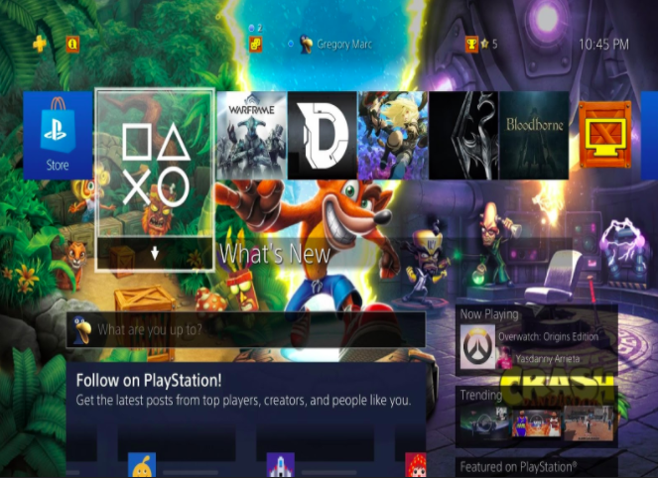

If the gamer is to press down from a game, they are introduced to the next screen below consisting of an immersive roadwork of community content, such as screenshots, livestreams,

and the progress of friends in the game, although more individually-tuned detail would require more button selections. We considered these elements when it comes to keeping track of friend’s activities concerning events. 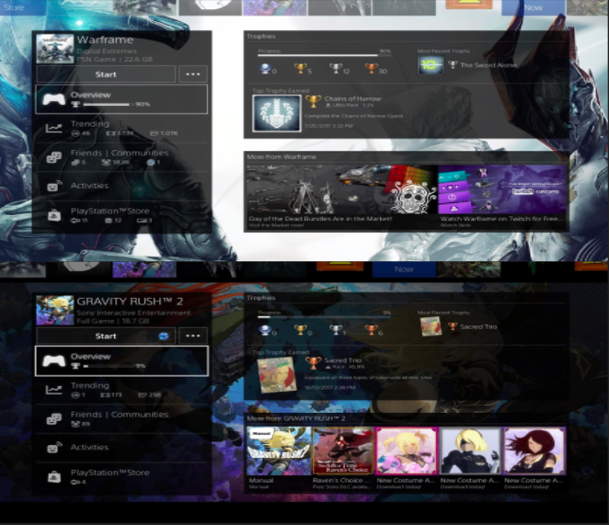

When it comes to defining a new social hub, it is hard to ignore the success of Snapchat and it’s worth for such a simple interactive design. The main communication media are pictures or videos, and a user’s content is only accessible to the friends they’ve added, with whom you can share pictures with or post them to your “Story”, all within the matter of seconds. People can add others by giving their username or letting others scan your QR Code in person.

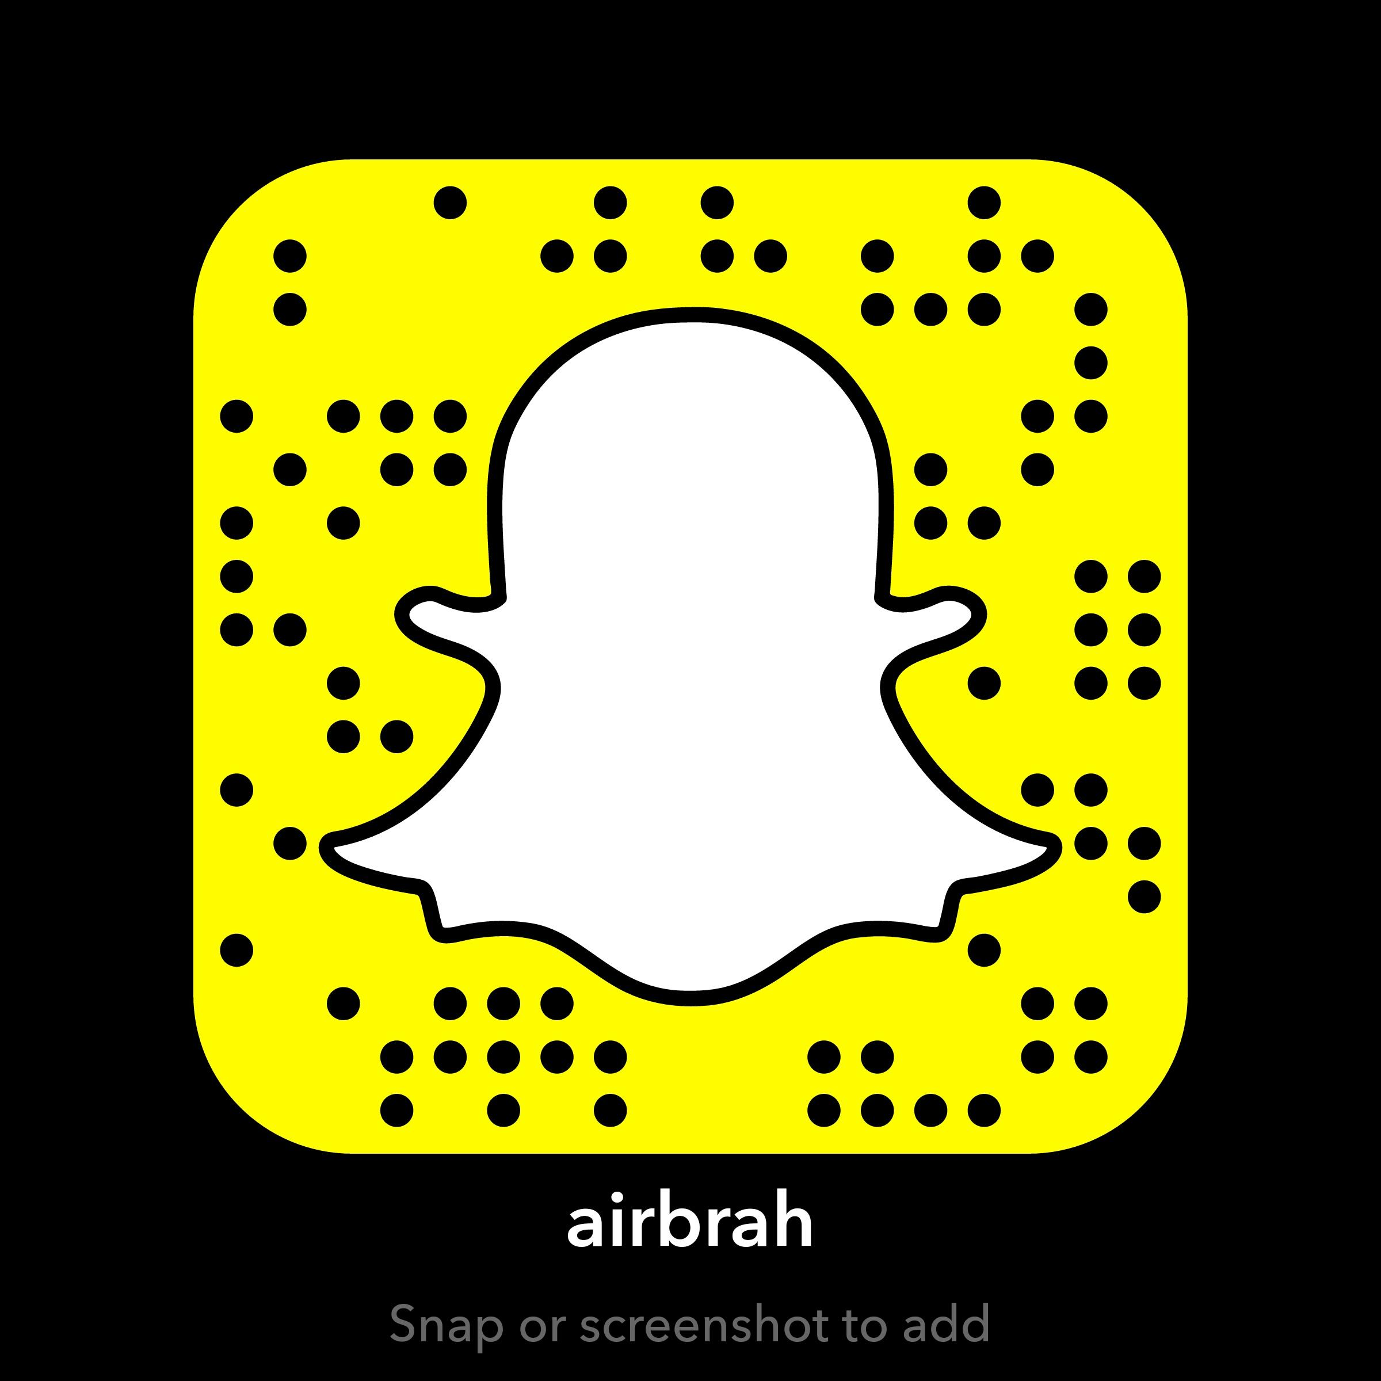

Your “Story” is a sequence of pictures you let your friends view for 24 hours before it is removed from their feeds and is no longer viewable.

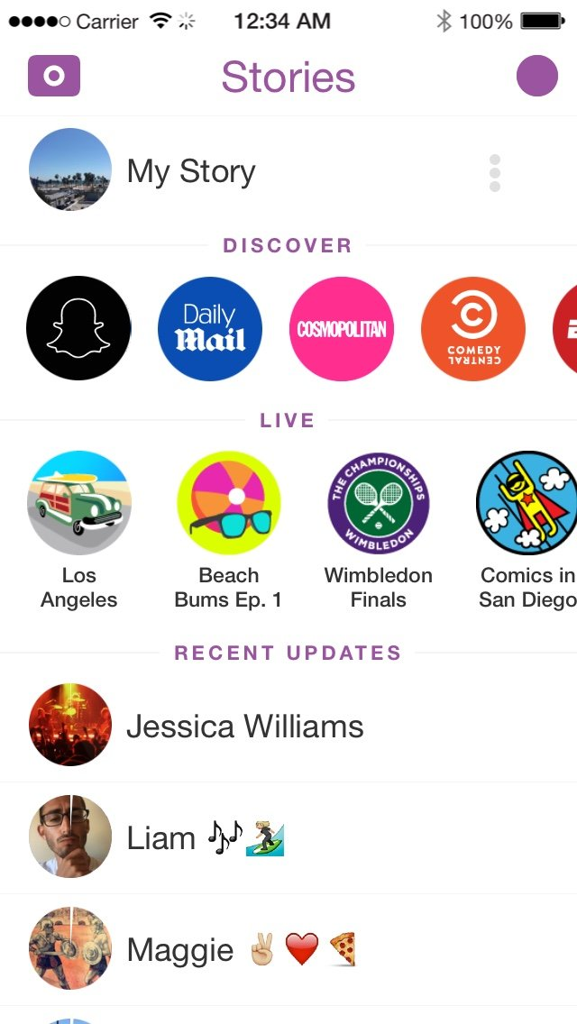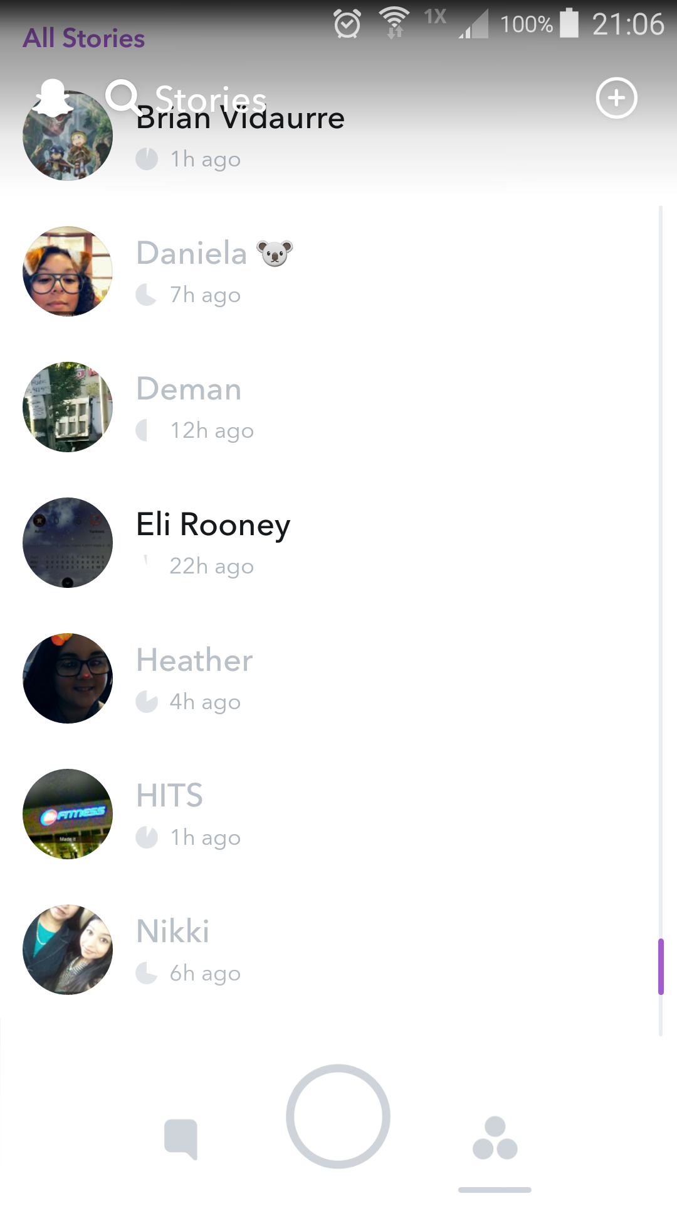

Whereas pictures sent directly to your friends are gone once they are opened (in which Snapchat allows your friends to screenshot your direct pictures).

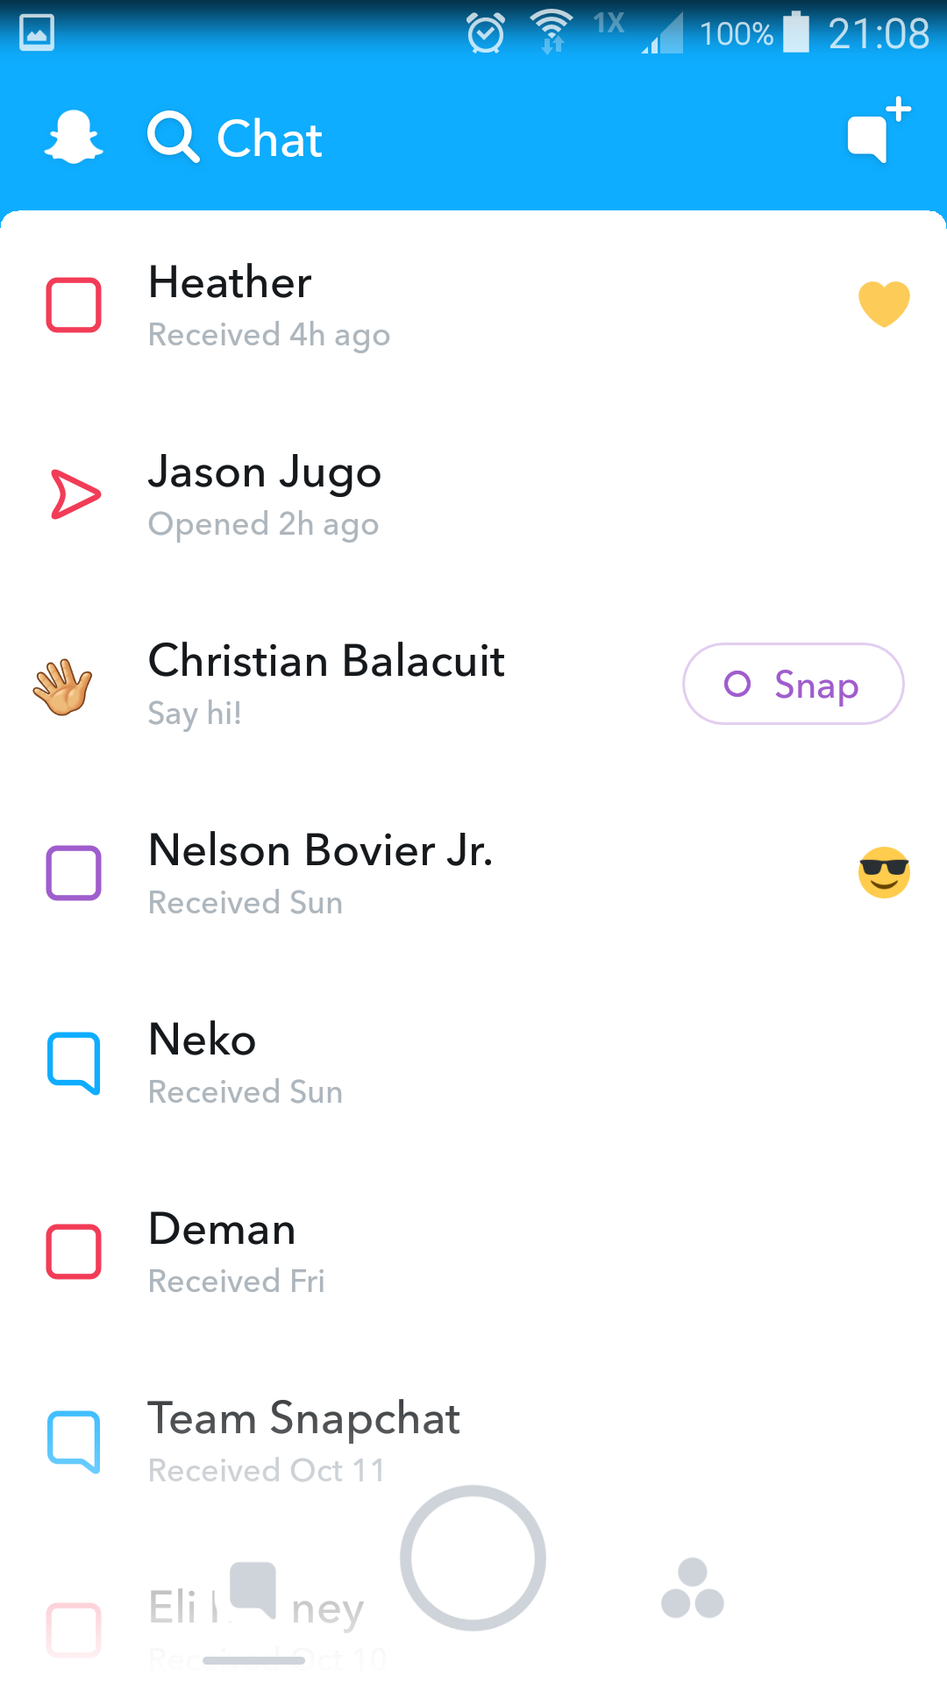

What we took out of this was the time-efficient way of sharing a snapshot of your life and your personality while avoiding the unintended cluttering of your friends’ feeds.

In considering a more dedicated to typed messaging, the chatroom platform Discord provides us with two big ideas. For one, Discord messengers can form servers and invite people into them, where they can also divide their chatroom into different categories and set the permissions on who gets to view and participate in those categories. For example, a club president can set up a Discord server and invite her fellow members (although they would not be able to join or see and post messages unless they have a Discord account). If the club is holding various projects, she can create new discussion boards corresponding to each project. She can also create a category exclusively permitted to club executives. These features are also exemplified by the other point of Discord we found, which is its relative ease to access and deploy its features, whether they are desktop, Web and mobile ports of the service. The screenshot below shows that the mobile version can provide a near-identical amount of substance of a chatroom as the desktop version with just the added requirements of a swipe right or left. 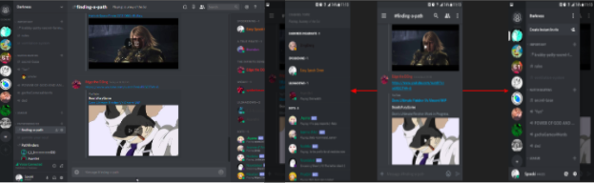

One of the things out right now that closely resembles what our app wants to be would be Meetup.com, which would not be as enticing without its group recommendation system as a factor. The feature combines location narrowing and matching of the user’s preset interests in suggesting groups whose meetups you are more likely to decide in attending than just . With Meetup, contributions to the group can still be made without having to attend every meeting, through features such as polls, discussion boards and proposing new events, and the advanced recommendation system can match up groups where one will have a higher chance of expressing this attentiveness.

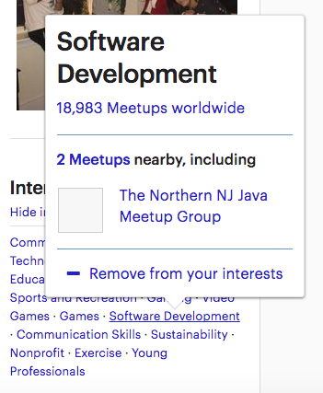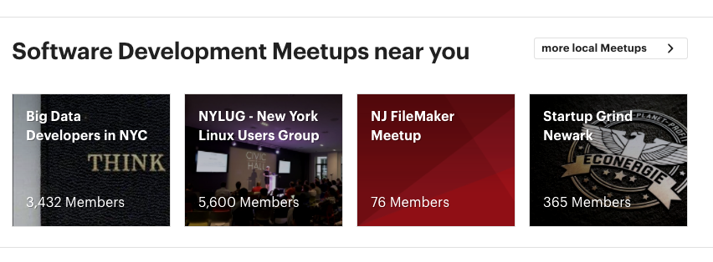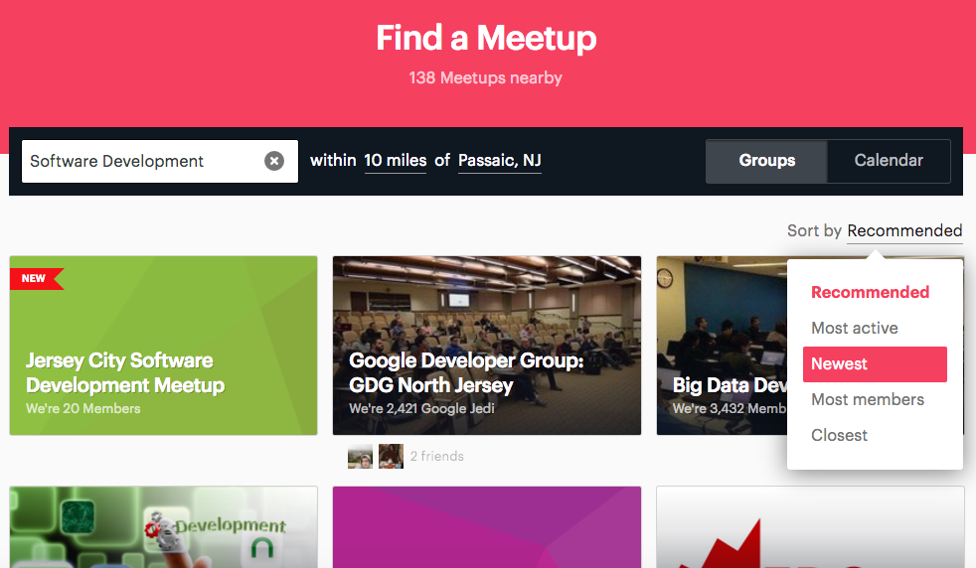

Lastly, we found that the simplistic model of Craigslist in organizing listings for the wide range of needs its visitors quickly browse and make listings for; yet, we also concluded it can be overwhelming for users who do not know what they are looking for. We took Craigslist’s category architecture as a suggestion in brief browsing of activities. For example, in the following screenshots the user can navigate from the very first page where they choose their location all the way to a local motorcycle for sale.

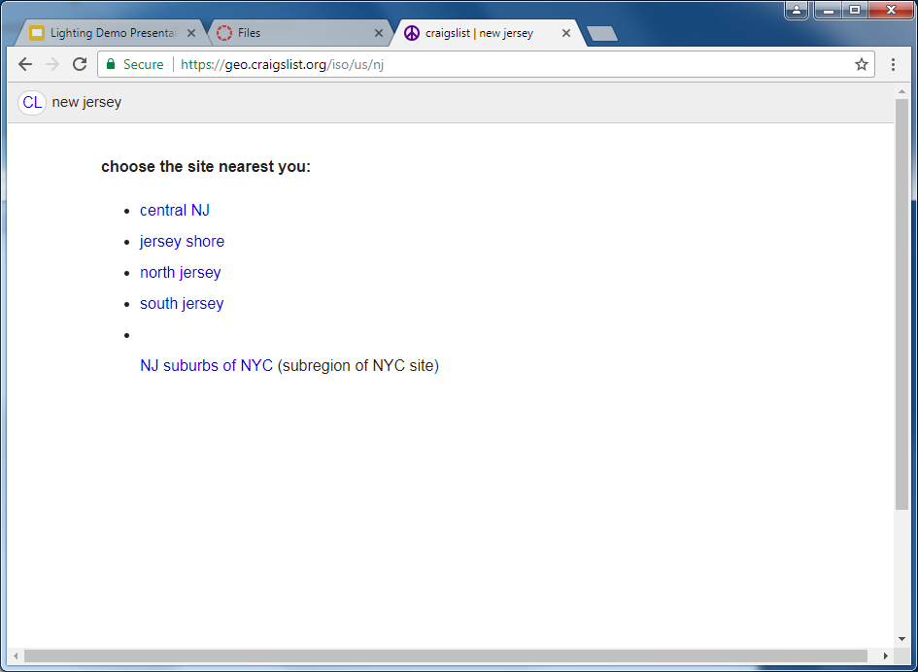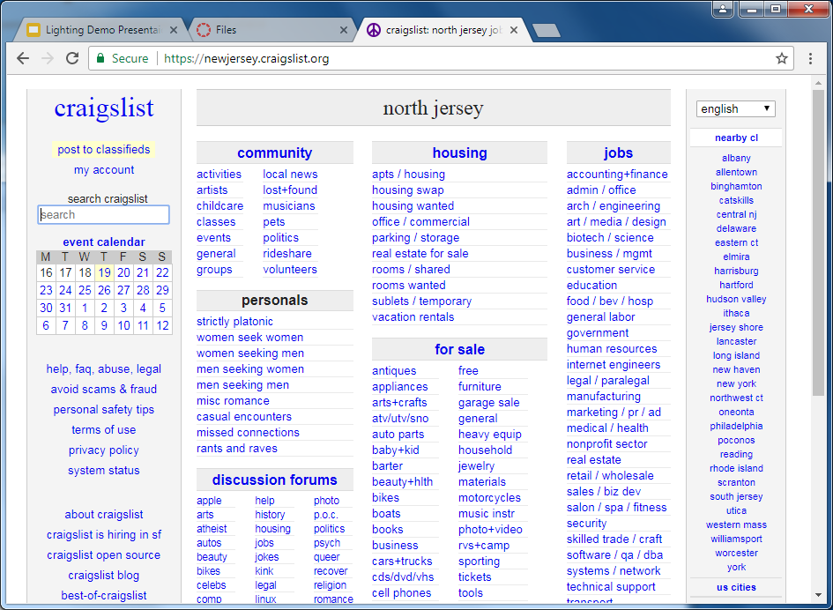

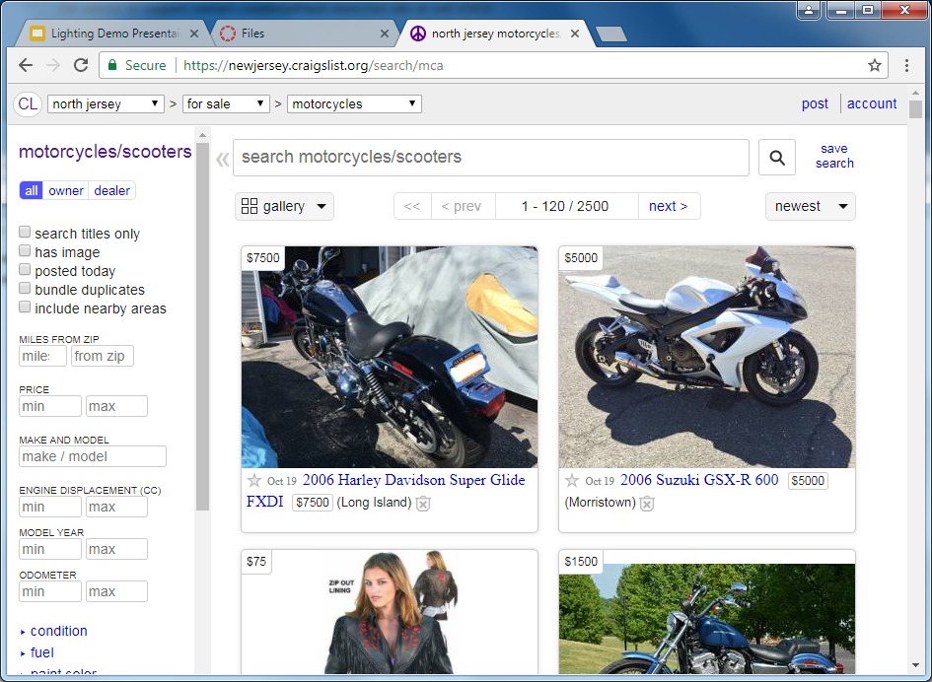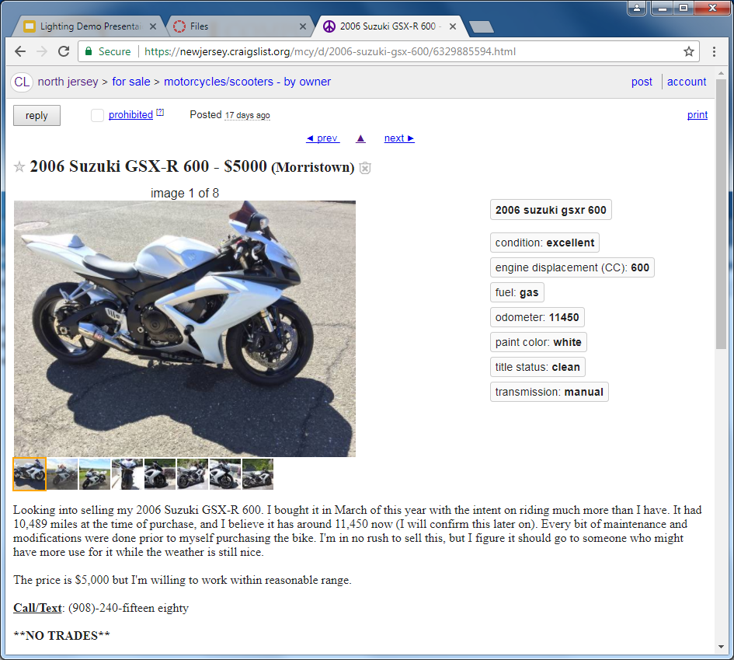

It was the big ideas extracted from some of these apps that were considered, but to not be copied, that would go into formulating our app’s vision of harboring a hub of in a way that has not been distributed before.

### Card Sorting and Vision Statement

The UX practice of card sorting requires the members of the group to use up Post-its to mark down sketches or an idea before sticking them on the wall before the members of the design group . To further compartmentalize our project’s features and vision, we construct categories that sum up the similarities of a bunch of cards and relocate our cards under them. Some categories that were drawn between our cards included the “Events” branch depicted on the left below, tying together ideas such as a livefeed and an event’s page (though, not the contents that make up that page). The adjacent image shows the cluster of cards we determined to fall under the “Friends” category, which suggested an idea such as a friend’s event feed and their online status.

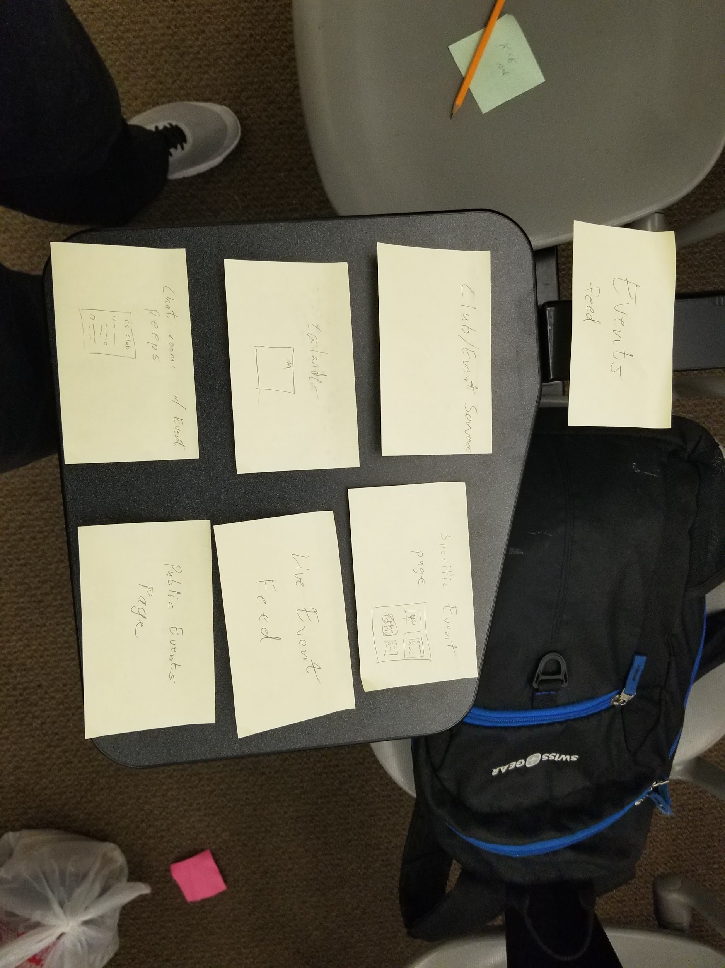

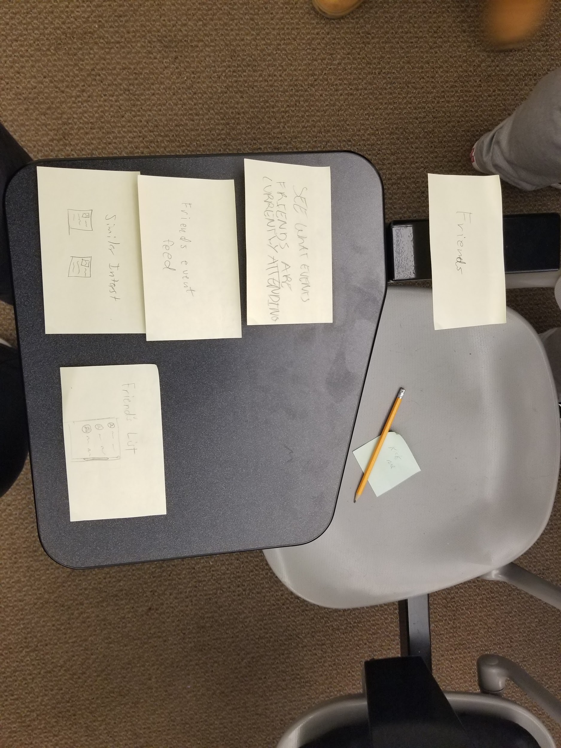

Another group that we drew from our cards are below on the left and are based around location, a factor that would be put in place with features such as real-time location scanning for nearby events and location pins for an event as a way for a user to be informed of it. To the right of the location cards are those pertaining to privacy, which was something brought up to concern our users’ preferences in showing what activities to display and to whom.

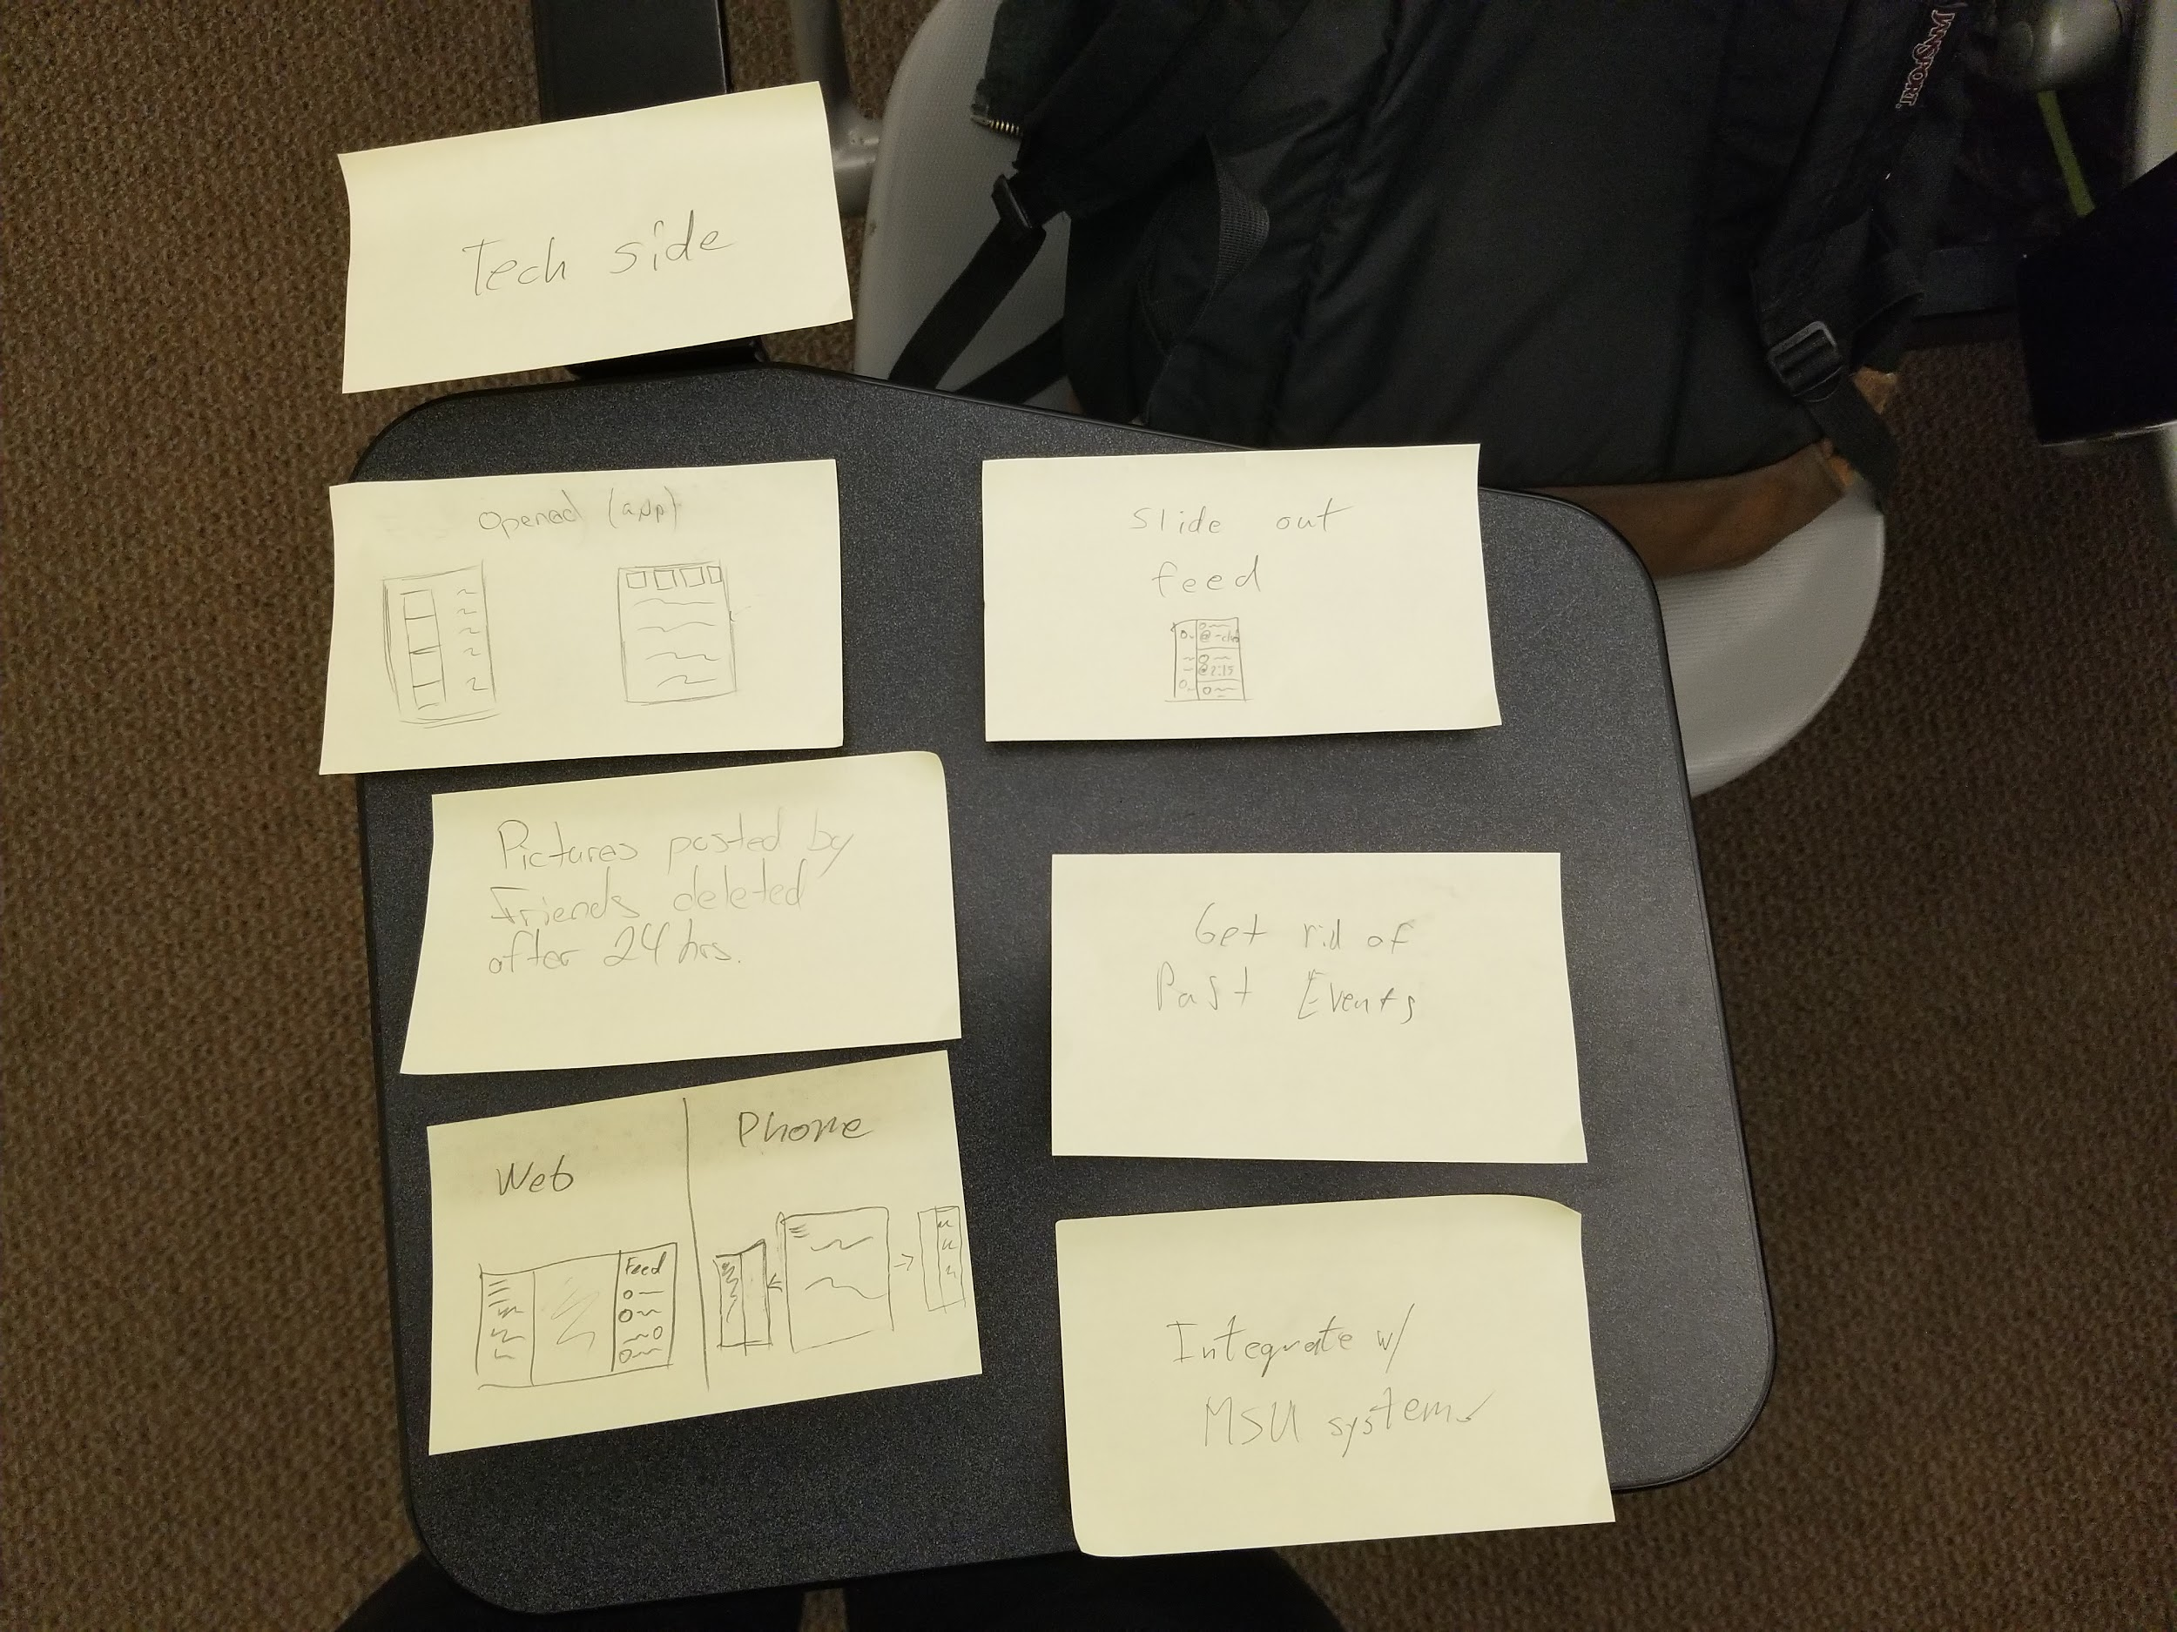 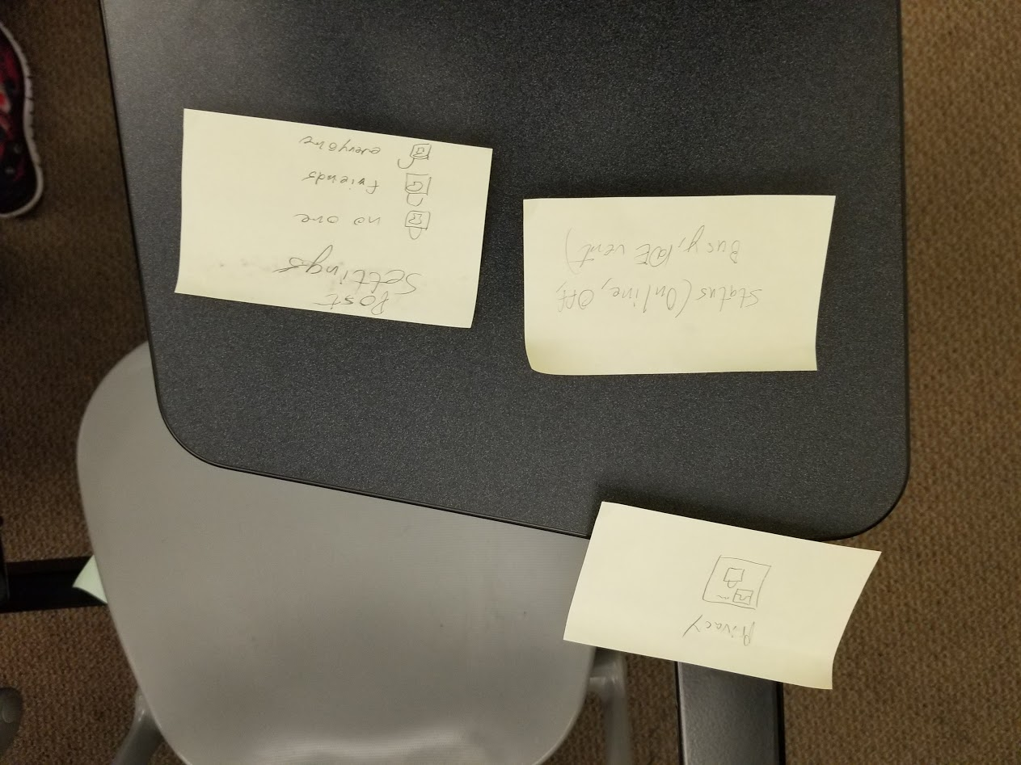

Being technology students, pinning up based on the technical requirements was bound to be brought up. A feeling of sync between the desktop and mobile versions would be vital in exploiting the advantages of both platforms. Close behind in the technology sector is the overview of the search feature encompassed by cards such as searching for events or people.

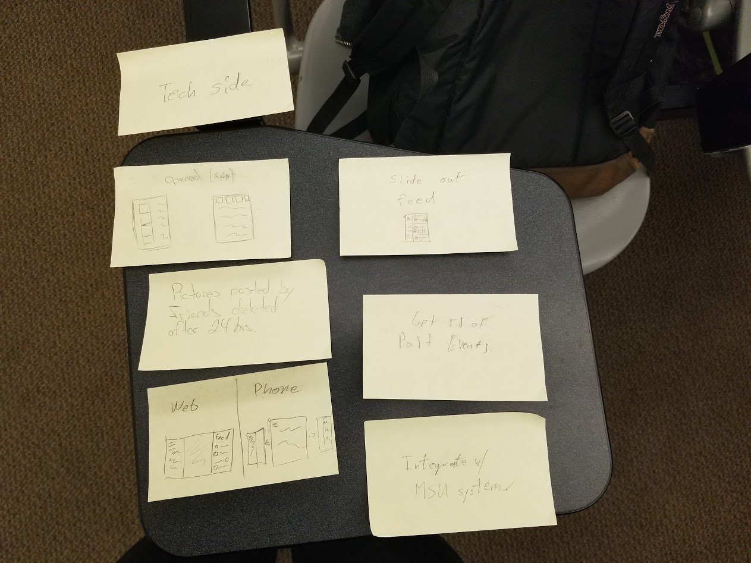 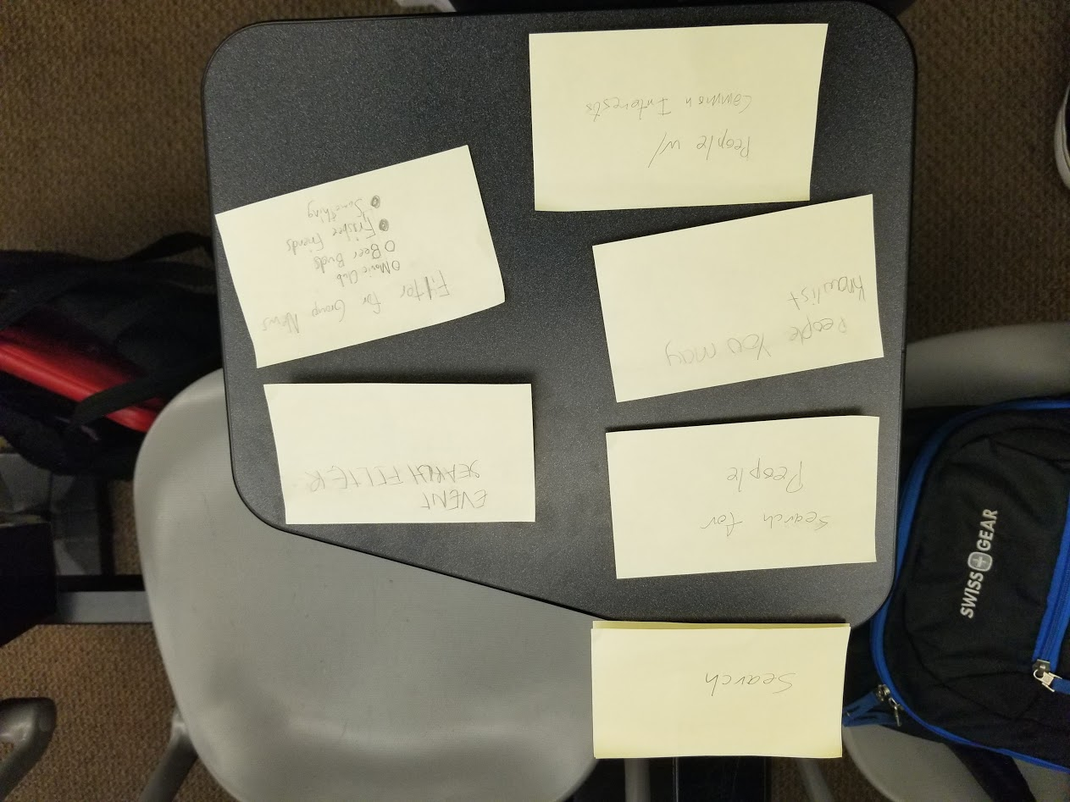

A lot of thoughts were put into our version of user profiles and what they would display in terms of showcasing event participation, such as video and photo galleries and a reward system. Finally, we fitted cards that envision our implementations of groups, in which users can join but don’t necessarily require to join in viewing or forming upcoming events, but are encouraged to join if they like an event that group has hosted.

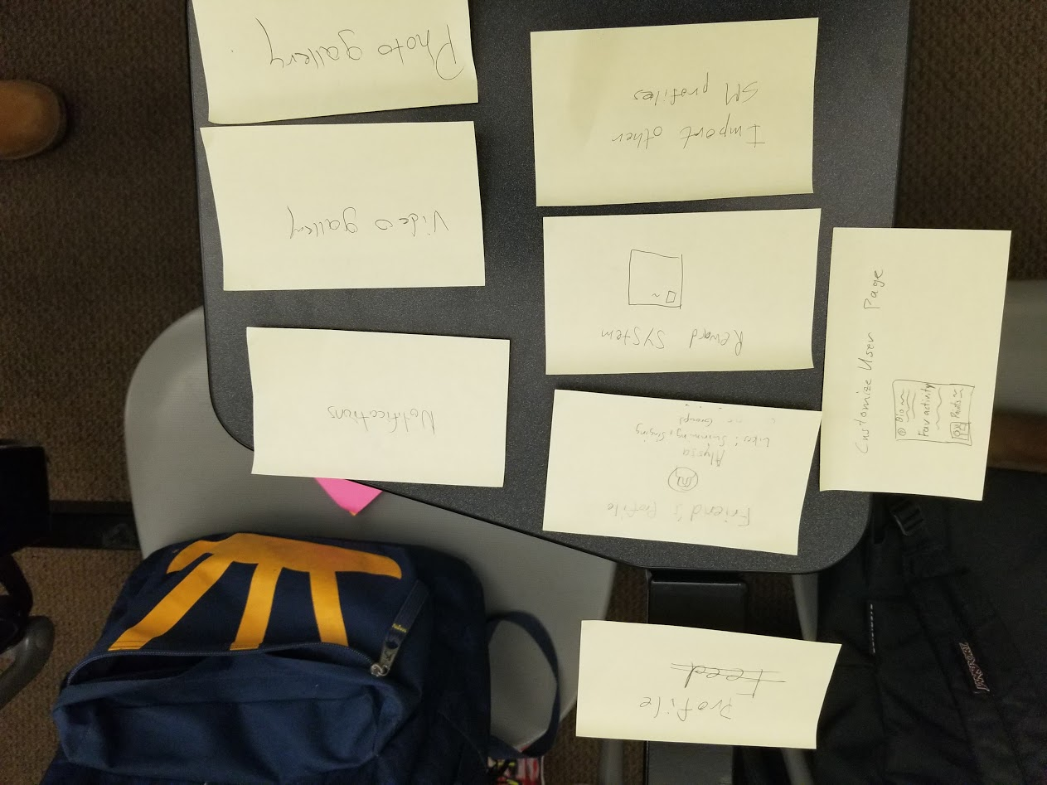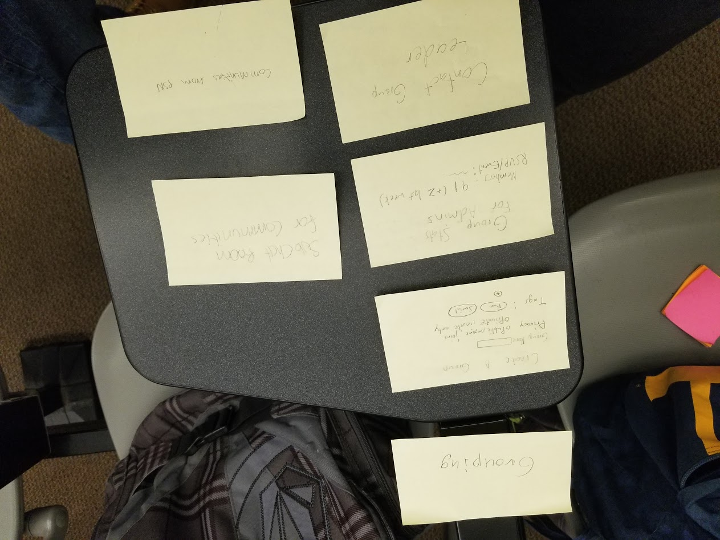

With the cards in place, we have begun to hone down in on our app’s unique vision of first year students at MSU getting an experience similar to attending an event without needing to physically be there.

### Context Scenarios

Now that he have the big ideas behind our app as well as our vision for what it should accomplish, we can begin to introduce our app into the lives of our personas through context scenarios. We progress through the same day covered within the problem scenario, but this time our persona has our app on hand to help solve some of the issues they faced. Within the context scenarios we look to see how our big ideas can help our personas with their individual problems, while not making their lives perfect or having them use every aspect of our app. Not everyone has a use for every part of our app, and we understand that.

Bob wants to attend the career fair after his class are finished. He attends the career fair and is there for a little over an hour. Then Bob proceeds to go work and arrives 20 minutes late. While at work, Bob’s friend calls him and ask if he is going to attend the mobile development conference. Bob couldn’t go to the mobile development conference because of work, instead he uses EventNow to see what is going on at the event. He notices a familiar name in the chat, whose name is David. Bob sends David a private message to ask him if he can send any update about the conference. By talking up David, Bob is able to keep up with the conference. There is a live stream for the mobile computing conference, but Bob doesn’t use that feature because he is at work.

**Bob Kooper’s Context Scenario and Storyboard**

It is Wednesday morning, Bob wakes up at 7:00AM and goes to the bathroom to wash up. After that Bob makes breakfast at 7:30AM. During breakfast, Bob opens up his laptop to post a listing for a meetup just before the career fair he is going to later in the day. His plan is to get a few people other than his friends to go to the career fair with him. He feels that having more people with him will help calm his nerves before going up to each of the panels. He finishes his breakfast by 8:00AM and then gets into his car to drive to Montclair State University (MSU). Bob has two classes today, which are Fundamentals of Programming I at 9:00AM and Computational Concepts at 10:30AM. Since he has a 15 minute break in between classes, he decides to check what his friends are up to with EventNow app. He notices one of his friends is at a conference about artificial intelligence that started at 10:00AM that he can drop into for a few minutes. He sees his friend there and they talk about what booths he wants to attend for the career fair he’s going to at 12:00PM with their other friend. Bob tells her that he feels that his resume looks like a barren wasteland with no experience related to the CS field. She tells Bob not to worry about it too much, but that maybe he can add general skills from working on class projects. Bob goes back to his classroom and spends his class time updating his resume. While updating his resume, he decides to check on his group meeting before the career fair. His friend and two other people have signed on to meet with him. As his class ends at 11:45AM, he rushes to the Student Center and meets up with his other friend who agreed to attend the career fair with him. He tells him he’ll meet back up with him at University Hall in a bit and goes to print out his updated resume.

After he gets back, Bob meets back up his friend, as well as the two people who responded to his listing, in University Hall. The four of them take the elevator to the floor where the career fair is at and enter the room and see many panels. There are so many that Bob questions whether or not he will be able to go to all the panels he planned to go to and speak to their recruiters. Before he came to the career fair he made a specific list of which companies he primarily wants to go see. Those companies were Amazon, UPS, ADP, and Colgate Palmolive. Although those companies were his primary focus there were 50 companies attending the fair and he wanted to hand out as many of his resume copies as possible. The first panel they want to see is UPS, which is Bob’s first priority on his list, so they get in line to talk to the recruiter. While waiting in line, Bob opens EventNow to see what other people are saying about the career fair in the public messenger channel. Bob learned that the Amazon and Colgate representatives knew nothing about the job specifics and seemed like they were only looking for buzz words. Bob ended up spending a little under 20 minutes just waiting in line, but he now has a good grasp on how to approach each panel. He managed to go to the panels he wanted to in an hour thanks to the information floating around on the EventNow app about the different panels.

Since it is now 1:00PM Bob leaves the career fair to get to his car. He rushes to the shuttle bus to lot 60 so he can get to his car by 1:15PM. Bob arrived at the parking lot and sped to work, but unfortunately he got there about 5 minutes late. Luckily his boss wasn’t there at the moment, so he managed to get away with it this time. While at work his friend called him to ask if he was going to the mobile development conference and workshop that starts at 3:00 PM. Bob had to tell his friend that he couldn’t attend it because he had work, but he said to post from the conference on EventNow. Bob’s friend told him he could try but no guarantees. Bob told his friend he had to hang up before he got in trouble but he’ll keep in touch through EventNow to see what’s going on at the event. He started chatting to people at the conference through the event chat on EventNow. He recognizes a few people in the conversation list from his class and decides to send them a direct message asking how the event is going. They each tell him a bit about what’s going on and Bob can piece together what the speaker is talking about. Some of them even send him videos of the conference itself. He talks to them for a bit here and there when he has time at work, and eventually they add each other to their friends list.

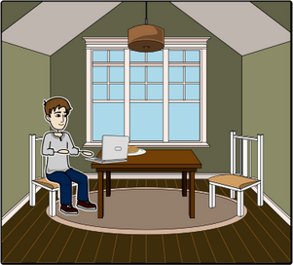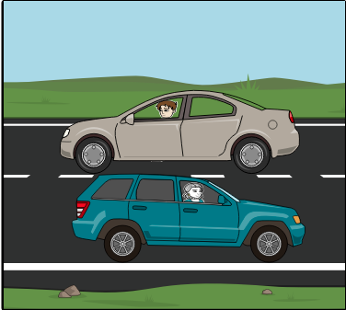 

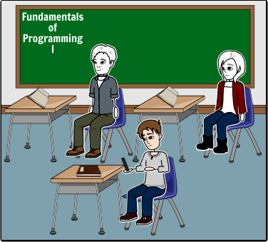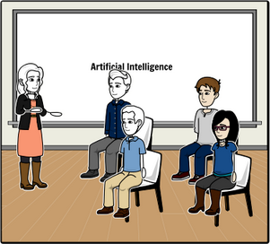



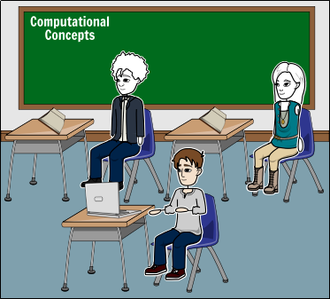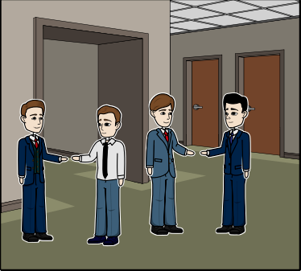

 

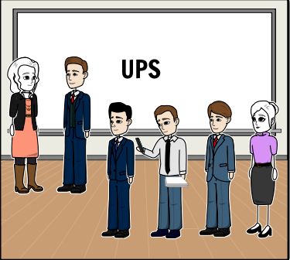



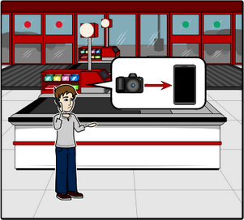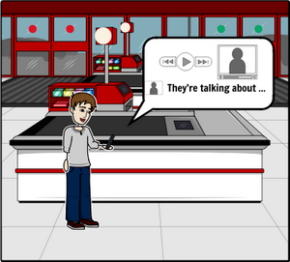

 

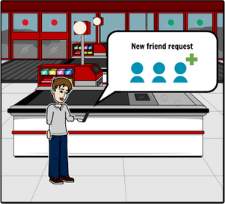



Tom wakes up to the EventNow app to check the daily events happen at MSU and notices a Japanese event and decided to check it out later during his free time. Durning Tom’s break, he hops on EventNow to check the Chemistry Club’s discussion board to see what the topic was going to be about and he likes what he sees. After meeting the people he talked to at the Chemistry club, he goes to work and looks up that particular girl he saw just before he left the club. He direct messaged her with a friend request. She accept the request and Tom is happy. Today for Tom was a successful and accomplishing day.

**Tom Veerman’s Context Scenario**

Tom wakes up on Tuesday at 7:00am. He washes up, gets dressed and heads to the train station to catch the 8:00am train to MSU. Tom never feels hungry enough in the morning to eat breakfast, so he just waits until lunch. When Tom arrives at MSU, he gets to his General Chemistry I class at 9:30am. During the class, he pulls out his phone and checks **EventNow** to see what events are happening right now. He finds out that a Japanese event is happening in the University Hall at 3:30pm. Tom decides to go to this event because he’s always loved anime and would like to meet some people he might connect with. He puts his phone away now and starts talking to his friends about the Chemistry Club and what they are going to discuss at 5:30pm tonight. Tom can’t make it to this event because he has work later at 6:00pm, but his classmates insist that he at least swing by and hear the discussion that they would have. Tom considers it. When class is over at 10:45am, Tom goes to his next class, Calculus I from 11:00am to 12:15pm. Once that class is done he has a break until his next class, University Physics I at 1:00pm. During this break, Tom decides that maybe he should take a look at the Chemistry Club and what they were going to discuss. Tom could only make the Wednesday meetings, not the Tuesday ones, but he does think it would be interesting to see what they talk about today. He checks his phone to see if any updates were made to the Chemistry Club page on **EventNow.** People in the discussion board are talking about certain topics that peak Tom’s interest. He definitely wants to go to the Club today now after reading that, even if he has to rush to the train station afterward.

Once Tom was done with University Physics I class at 2:15pm, he goes to the Student Rec Center to eat his lunch. After he's done eating, he checks out the Japanese event at 3:30pm. Tom enjoyed some of the people there at the event, but he wasn't really clicking with these people at the event. They liked the newer animes whereas Tom likes the old fashioned animes. It’s 5:15 pm now and Tom starts heading to the Chemistry Club. He gets there on time and hears the discussion they have. There are a lot of interesting people there that he recognizes as the people on the discussion board on **EventNow**. Time moves quickly and it’s 5:35pm. Tom needs to hurry and leaves the Club’s room to catch that train for work. Just before he turns around the corner of the hallway, he notices a gorgeous girl walk past him and enters the Club room. Tom has never seen her before. She must only come to the Club on Tuesdays. Tom can’t stop to talk to this girl, he’s got to go. He quickly gets to the train station and makes it by the skin of his teeth.

Tom makes it to work in one piece. During his shift, he thinks about the discussion at the Club and that girl he passed. He decided to take out his phone to see if he could find the girl he passed was on **EventNow**. In the Chemistry Club page, he recognized her by her profile picture and decided to add her as a friend with the following message: “Hey, I think I noticed you on my way out of the Chemistry Club. Sorry, I was in a rush to work. Wanna be friends?” After his day at work, Tom heads home around 10:00pm. Before Tom goes to sleep, he checks **EventNow** to see if the girl responded. She accepted his friend request and message back: “Hi! I did notice you on your way out! That sucks that you had to go because of work =( We could get together Friday to talk some more on that topic we went over in Chemistry Club if your free.” Tom found out that she’s a Computer Science Major who had a interest in chemistry on the side. Tom replied: “Sure, sounds like a date. Have a goodnight. =)” She replied: “Yey! \(^o^)/ Nighty night!” And on that happy note, Tom falls asleep at 11:00pm. Things are looking up for Tom. More things await for him tomorrow…

Now that Sinbad has been introduced to our application, he finds use for it within one of the few weekends he finds that there is no work to do. Unfortunately for him, he can’t contact his friends because they all have plans. Fortunately for him, there are events he may enjoy near him. And so, Sinbad decides to take a look at what these events can offer.

**Sinbad Ali’s Context Scenario**

Due to Sinbad Ali’s schedule he has been so busy he can’t go attend all the events that he would like to go to. One day he spoke to his friend from the CS club, who told Sinbad about an app called EventNow. It was the end of the week as always and it is time for him to catch up on work. As he looked at his list of things to do he realized he is caught up on work and has nothing to worry about for the weekend. Now he has the weekend to spend freely on whatever he wants. Unfortunately it seems to be too late to message anyone to see if they want to hang out. Everyone has already made plans and no one is available.

Sinbad remembers the app his friend told him to download on his phone called EventNow. He tries to take a look at what is going on around his local area. He sees that there are some local bands playing in the area and tries to check out the livestream of the event on his phone. He scrolls down to the comments and he can see that the venue is pretty much dead. People are saying the band is lackluster and the crowd is dead. The live feed of comments are saying not to go check out the show and people should go elsewhere to spend the night. Sinbad keeps checking out what is going on around the area and he sees that there is a hiking event about to start at Vernon, NJ to climb the trail called the Stairway to Heaven. The one thing that Sinbad loves to do more than anything is hiking so he jumps on the opportunity to go and meets with a bunch of random people who are also attending the event.

Once he got to the event he felt very welcomed by all the strangers attending the event. They are all nature lovers and they were all exchanging stories about their hiking adventures and all the things they have encountered in the forest. Before this Sinbad didn’t have anyone to hangout with for the weekend, but through attending this event he was able to meet a bunch of people who share similar interests as him. He is planning on hanging with his new group of friends the next time he is available. If they aren’t, he is think he can use the EventNow app again and see what else is going on in the area hoping to meet more great new people.

### Key Path Scenario

A key path scenario is a run through a prototype of our app, focusing on covering the important interactions that our personas would have with our app. Because most of this semester project centered around a single persona, namely Bob, we designed our key path scenario around his unique problem. As such, the app has limited functions in this stage, as it really only needed to accomplish what Bob would wish to accomplish so as to use as much of the time we had to make his key path scenario functional in its entirety.

<https://id0cwi.axshare.com> - Link to use app as shown below

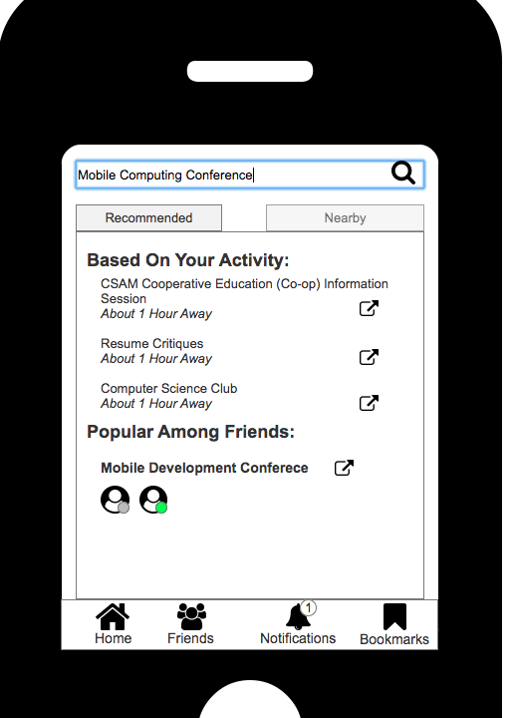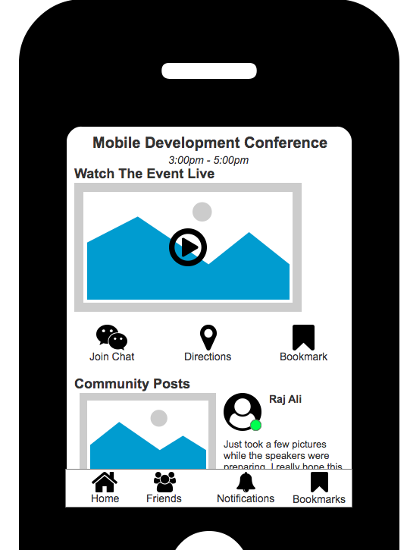

 

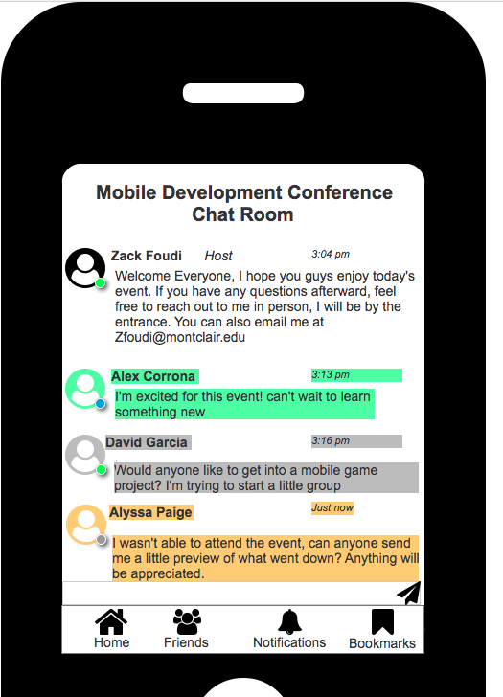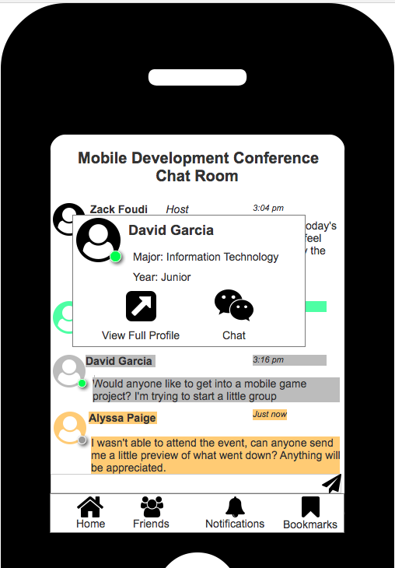

 

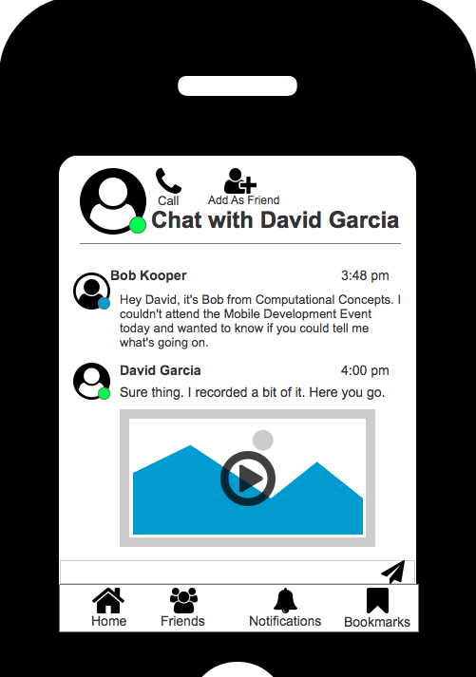 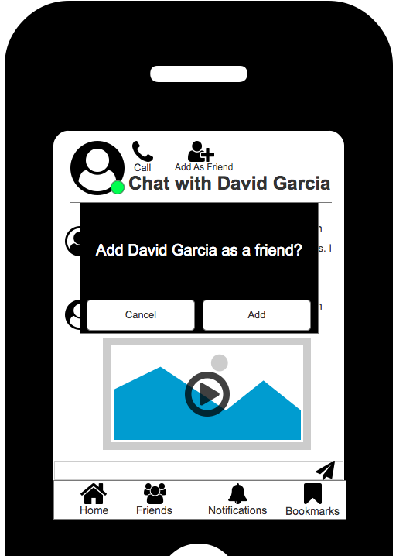

 

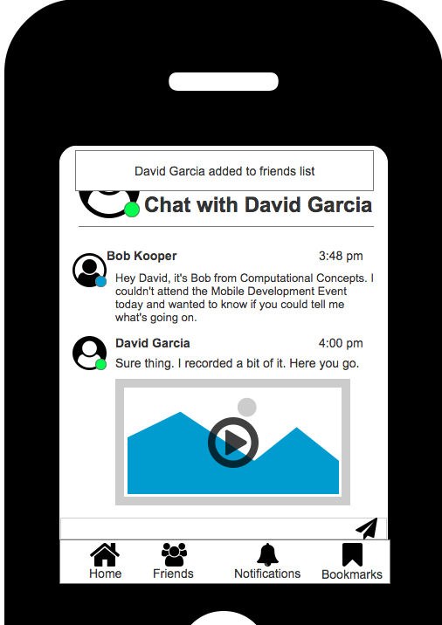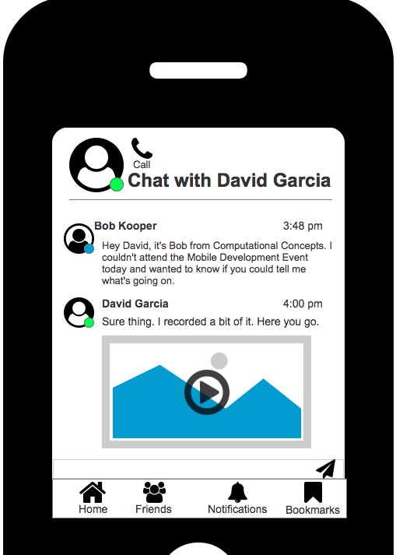



### Usability Test

In the usability testing portion of this project we first draft a prototype of the solution to our potential user to problems. We first look at our application layout and design and came up with a simple GUI that the user will be able to easily navigate through the app. Second, we draft a prototype in axure as a static designed layout. We took into consideration how our persona will use the app and how would the persona interact with the app. The persona we chose to use during the testing phase was Bob Kopler, because he struggles to make new friends and make new connections with others. Since we are designing an app for someone that wants to make new friends and make new potential job opportunity connections, it made send sense to use Bob. However, after we presented our Axure designed to the class, we proceeded to make the app interactive for the user. We used the axure transition features to create a working prototype of the application. After we perfected the interactive portion of the app we proceeded to get interviews from potential users of the application as if it was to go on the market. During the interviewing process we ask the user what did they like about the app? What would they like to see changed in the app? Was it easy for the user to use the app? One user that we interviewed thought the app was a great idea, however became frustrated because the app was not fully functional. The user claimed that because he is not a technology person he found the application hard to use when it is not fully functional. Here is a video of the actual interview with this user <https://www.youtube.com/watch?v=U4l6C46OCpc&t=190s>. Our goal during this phase was to receive information on what we need to improve on for the average user of the EventNow app.

Since this was our first interview for usability test, many things went wrong. The interviewer gave too much information about the app to the interviewee ( user) before he even asked for the functionality. The interviewer should have waited for the user to ask questions regarding buttons and functionality before giving any information but instead the interviewer started explaining the app to the user which caused the user to become confused. The interviewer should have given the user full freedom on what to click and where he navigates without influencing him and telling him what the buttons do. The interviewer should’ve waited for the user to click on buttons and where he navigates and then ask the user why he did such thing to get his perspective. In future for usability test, the interviewer should be prepared with flexible questions and have an overview of what he wants to ask and achieve. Furthermore, the interviewer would not explain every functionality of the app and tell the user where to click and navigate to. This approach will allow the user to feel free and do what he wants while the interviewer just observes him and finds out how to improve the functionality of the app to make it user friendly.